The Voice Of The Tingleys
Volume 15 Issue 1 March, 2007

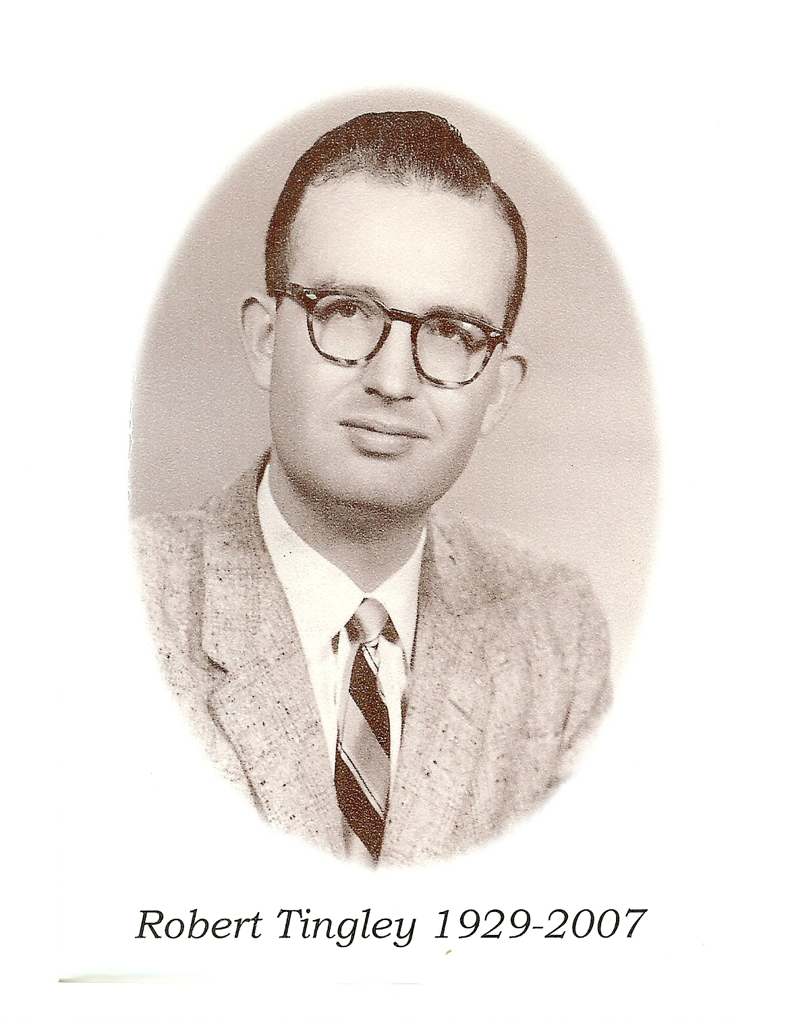  (FROM PATTY)  Robert Guy Tingley was born June 16, 1929 in Huntington Park, California, to Doris Marjorie Brookhouser Tingley and Harold Nelson Tingley. He weighed in at a whopping 9+ pounds. His mother always swore up and down that Bob was born 6 weeks late and that was why he was late ever since. His Dad, Harold, got into trouble and was away before Bob was born, and was gone till he was almost 5 years old. Bob and his Mother lived with his maternal grandparents, Grama and Grandpa B., his doting Great Grama Marks and Chuck, his 9 year old Uncle. Bob was the apple of his grandparents eye for the rest of their life, and they doted on his every move.  Dad returned home when Bob was about 5, and shortly after, brother John arrived. I, sister Patty, arrived when Bob was 10. Bob was a quiet serious boy and grew into a very handsome man who was liked by all. Bob and John used to tease me a lot! Bob used to baby-sit me while Mother worked during the war, and he was the world’s most  (continued from cover)  He and Celia spent a lot of holidays with us, and we always looked forward to them coming. Bob and Celia moved to Avilla Beach a few years ago and they came to LA often and spent many wonderful nights with us.  Bob passed away March 7, 2007. He fought a 15 month brave fight with MDS (Myelodysplastic Syndrome) which recently turned to Leukemia. Bob always felt he would be put in remission and his family always felt like a cure was right around the corner for him. It was a total surprise when Bob got so sick so fast.  I could not have asked for a better big brother than Bob. He was always there for me and my family. When he got back from the Korean War, he didn’t have a girlfriend yet, so he took me to movies and out for dinner a couple times a week. If he thought I needed something he bought it for me. He was the one who walked me down the aisle at my wedding. Even though Bob was 10 years older than I, he treated me like we were the same age. When our Mother was so sick, Bob went out of his way to help in any way he could.  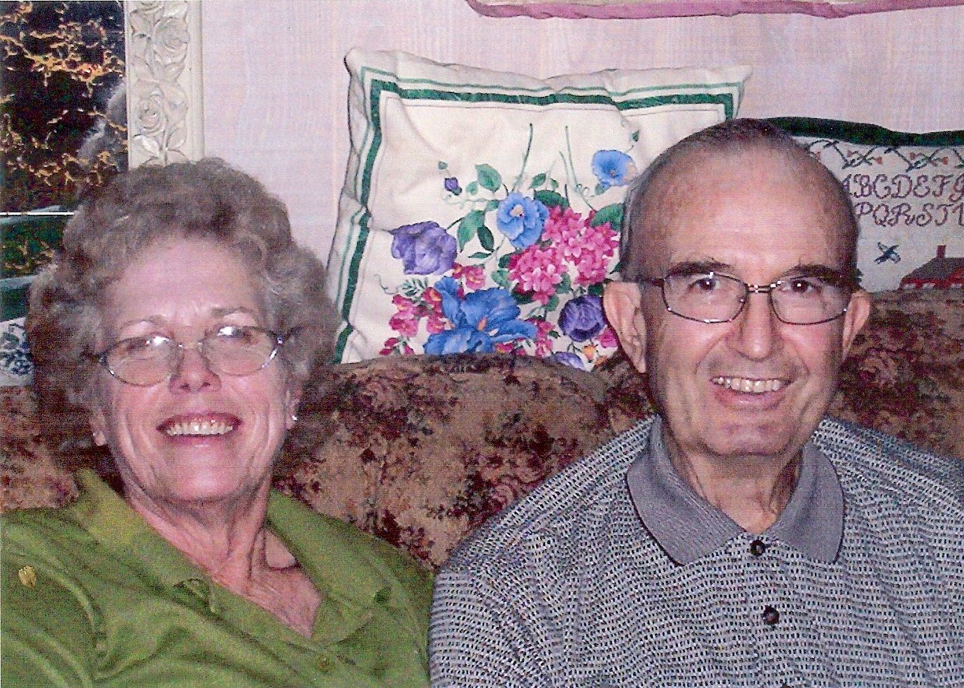  Patty and Bob  Bob leaves behind a legacy of warm and lasting relationships: his wife, Celia; his brother John and sister-in-law Mable; sister Patty and brother-in-law Jerry; nieces Michelle, Daphne, Rena, Susan, Julie; nephew David; great-nephews John Seth, Jeffrey, Anthony, Brian, James, Little | absent-minded baby-sitter. I used to give him a run for his money & got him in trouble a lot with Mother.  Bob was in the Korean War, and graduated from UC Berkley with a BA both in Astronomy and Engineering. He really didn’t date much till he was past 30, as he was on the shy side. He married Betty, but she passed away after a few years. A little later he met the love of his life, Celia, and they have had 27 years of a very happy life. They have lived in both California and Texas, and have had a lot of fun moving around, meeting new people where ever they went and always discovering new adventures. Bob was instrumental in starting up Mensa Groups where ever he went. Both Bob and Celia have enjoyed the association with their Mensa friends. I always enjoyed receiving Bob’s  e-mails about their activities.  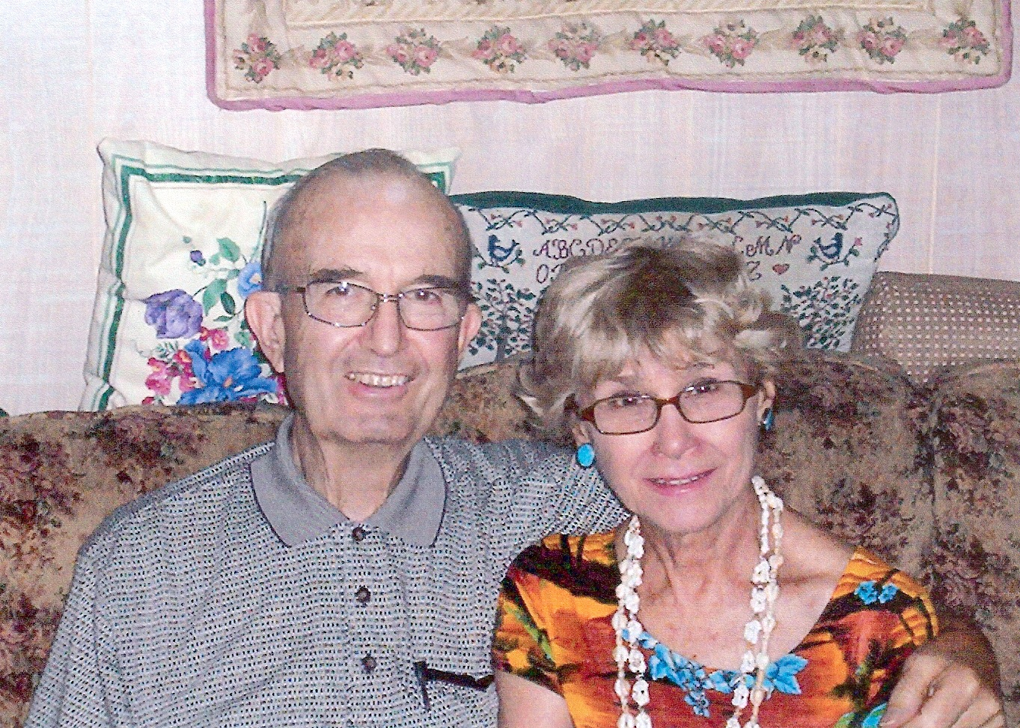  Bob and Celia  Bob had an interesting professional career. He worked at Douglas Aircraft, and helped design the first rocket, the Nike Zeus, that went into Space. He also worked for Motorola, but retired from Mc Donnell Douglas, that later became Boeing.  Bob was tall, dark and handsome, and I can never remember him ever doing or saying a mean thing to anybody or anything. He was always willing to help or do anything he could to help someone. Everyone loved him! He had a very quiet demeanor about him and he always made you feel good when he was around.  (continued on Page 2  David; great-nieces Heather, Michelle and Amara. He also leaves a half-brother, Harold Nelson Tingley, Jr. (Bud), and family.  It has been a privilege to have Bob in our lives as loving husband, son, brother, uncle and friend. His quiet but humorous personality has added much to our lives. Bob lived life to the fullest, left nothing undone, and made the life of those he touched far better for the experience  (FROM JUNE)  As I sit and think about our cousin Bob, the first thought was that he was a kind person, a real gentleman in all aspects of his life. It was fun to be around him. I have always looked up to him. He will be greatly missed by all.  Our Tingley Reunions have helped to keep the Tingley cousins together. May God bless the memories of him, our dear cousin Bob.  (FROM FLORENE)  Bob was always kind to me. He always made me feel that he liked me. He always made me comfortable.  My earliest remembrance of Bob is when I was a child and he was, well I don't know how old he was. I only know that he was older than I. I have always been in awe of him because of his intelligence, which is no secret. At that earliest remembrance, we kids (Bob, my brother Glenn, my sister Edie, Johnny, and Patty) were in a car and we were talking about who knows what, but Bob wasn't talking; he was thinking. I think that it was Johnny who said that Bob was thinking, and that he was very smart.  At the Reunions, he liked to be involved with what was going on. He was also willing to talk about whatever I wanted to talk about. I valued his opinions, his intelligence, and his kindness. He will be missed.

From the Editor-

This edition of the Tingley Times will be brief. It has some very sad news about our cousin Bob who passed away on Wednesday, March 7. And then there is some happier news about our Tingley Reunion on August 3 – 5, 2007.

Being raised in Alabama, I was not privileged to know Bob as well as you California cousins. The few times I got to be with him were always memorable because of his friendliness and ability to make you feel that he was genuinely glad to spend time with you. I loved him because he reminded me so much of his Mother, my Aunt Doris – whom I loved and appreciated so much. She and Uncle Harold spent some time in Birmingham when I was a teenager.

Our love and prayers go out to Celia, and to Bud, Johnny, and Patty for God’s special comfort during this time.

We are looking forward to seeing all the Tingley cousins and their kids in August at the Tingley Reunion. Please try to make it – we all need to be together while we are able. See you at IDYLLWILD!
Alice Tingley Schafer

  LOOKING AT THE STARS  Gentle Man is Gone but not Forgotten  Our cousin Bob Tingley passed away on March 7th. This came as quite a shock to most of us. Bob was at the last Reunion and in seemingly good health. I am so thankful that so many of his family were represented at the last Idyllwild Reunion. We send our deepest sympathy and love to Celia for the loss of her dear husband. To Patty and John and Bud, we know how you must feel and send you our love and understanding with what you are going through.  I have wonderful memories of Bob. His quiet manner was quite unusual for a Tingley! My mother and dad were very close to this family. I was born in the Brookhouser's home in Huntington Park. Bob's grandmother was the nurse in charge. The thing that comes to my mind when I think of Bob is his interest in astronomy and his quiet nature. To me he was somebody that I looked up to, not just because of his intelligence but it was his personality. He reminded my so much of my husband Jim in many ways. Bob was always smiling and seemingly in a happy mood.  Dick and I were talking on the phone about Bob and the telescope that he made when he was very young. How did he do that? He would show us the North Star and the Milky Way. Other stars in the constellation were mentioned but sometimes we did not understand what he was talking about. We just stood there and were amazed at his knowledge.  I am so thankful for the Reunions & how well we have kept in touch with each other. Grandma and Grandpa would be so happy knowing this. The cousins that are gone are remembered in many different ways and are loved and appreciated. How can we remember Bob?  By Looking At The Stars  Love, Betty | REACHING FOR THE STARS  The sudden death of our cousin Bob was a shock and a great sadness to us. I want to express my sympathies to his wife Celia, brother John and Patty, and to Bud.  We are never prepared to lose someone we love, but as we get older we realize our life here on earth is really a short time compared to eternity.  Now we have love for one another and hopefully good memories. At our last reunion I noticed Bob looked so strong and well. He was laughing and joking with John and had a great sense of humor. He was enjoying life.  Now a memory has emerged of when we were all children here in California. My mom and dad often took us to see Uncle Harold, Bob, John, Patty and mom, Doris. Uncle Harold had a beautiful back yard which he would show us.  Then it was fun time for all us Tingley cousins together. John was the same age as Betty and I,.. and loved to tease us. Patty was my brother’s age and always had a doll in her arms, Bob was a few years older but much more mature we thought.  As the sun began to set he would set up his telescope, then he would ask if we would like to see the Milky Way and the North Star. He then positioned the telescope for a couple of 8 and 9 year old girls, then say “look here, ……do you see it”?  Of course Betty and I had no idea what we were looking for, and we didn’t want Bob to know his cousins were a couple of “dummies”, --- “oh yeah, we see it” I said. I suppose I was expecting to see the Milky Way candy bar.  What I am trying to say is we were more impressed by his age and Intelligence than we were by the Stars, HE was our STAR. He will always be remembered by his quiet, gentle manner. As we look up into the night skies, and see the moon and stars, there will be that sweet memory of Bob Tingley.  God bless Bob and his family. See you soon, if not in this life then the next. Always be ready to meet our Lord, as time is short for us seniors.  Love, Dorothy Tingley Stead  P.S. Cousins gone, but not forgotten: Pat, Marjorie, Billy, Glenn U., Barbara, Jack, & now BOB. God bless the memories of these dear ones.

WHAT? IT’S NOT LAKE SISKIYOU? WHAT DO YOU MEAN?

We have completed an in-depth look at Lake Siskiyou in Northern California as our gathering site for our next Reunion, August 3, 4, & 5, 2007. Although Lake Siskiyou is a beautiful place to vacation, we have decided that the cabins are too expensive and the distance is too far for most of us.

Back by popular demand, we will be having our Reunion at Idyllwild, the heart of the beautiful San Jacinto Mountains. You need to make reservations for cabins by calling Idyllwild Inn at (951) 659-2552 or toll free at (888) 659-2552. We will be meeting at Dorothy and Ron’s campsite on Friday night when we will complete our plans for the weekend. I hope we can eat at the Mexican Restaurant, Arriba, on Saturday night. I really enjoyed eating there. What do you think? Saturday afternoon games for the more energetic Tingleys? Fun for all!!!

In this issue of the Tingley Times is a map and information on Idyllwild County Park. Also you will find information on the Idyllwild Inn. Check their website: idyllwildinn.com

HOPE TO SEE YOU AT THE REUNION – AUGUST 3, 2007!!!!!!

from Betty Crowell

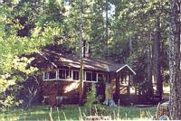 |  | 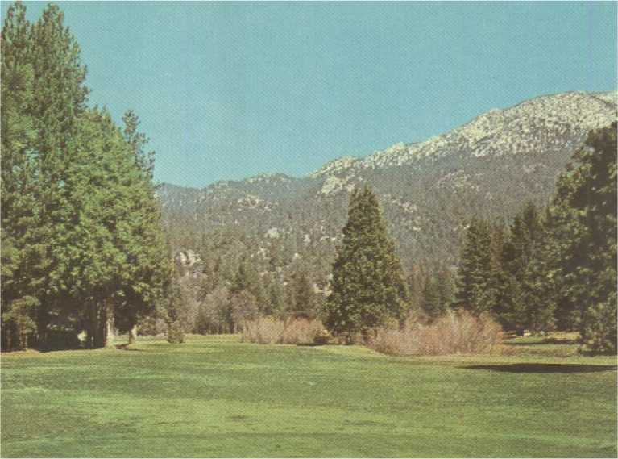
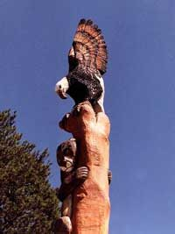 | 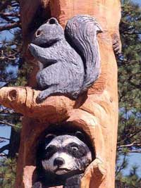 |  | 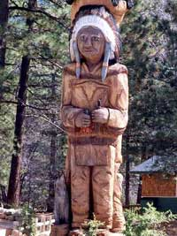 | 

